Archers’ Forms

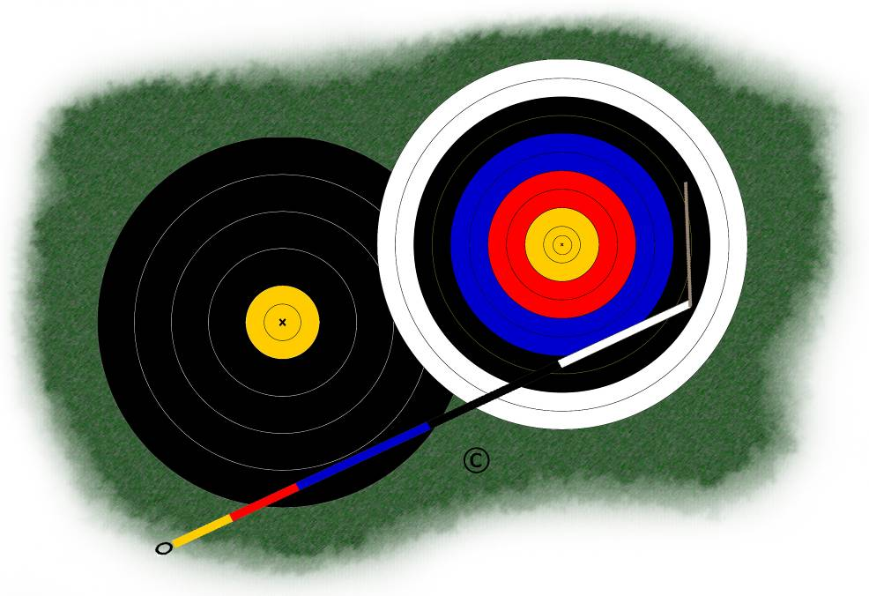

Personal Archery Equipment Details
Arrow Spine Record

Name:
Club Name:
Arrow Set:

Measurement Results
Manufacturer:
Model:
Spine (nominal):
Date Purchased:
Date First Used:
Date Arrows Spined:

Arrow No. |  | Weight | Spine Range | Measured Spine
(Initial) | (Final) | (gr)
1 |  |  | -
2 |  |  | -
3 |  |  | -
4 |  |  | -
5 |  |  | -
6 |  |  | -
7 |  |  | -
8 |  |  | -
9 |  |  | -
10 |  |  | -
11 |  |  | -
12 |  |  | -

Measurement Results
Manufacturer:
Model:
Spine (nominal):
Date Purchased:
Date First Used:
Date Arrows Spined:

Arrow No. |  | Weight | Spine Range | Measured Spine
(Initial) | (Final) | (gr)
1 |  |  | -
2 |  |  | -
3 |  |  | -
4 |  |  | -
5 |  |  | -
6 |  |  | -
7 |  |  | -
8 |  |  | -
9 |  |  | -
10 |  |  | -
11 |  |  | -
12 |  |  | -

Method
The following steps describe the use of this form and the basic method for using a spining jig; as different models of jig will vary, it is not possible to provide detailed instructions here on how to use the jig itself. This document also does not set out to explain the reasons, advantages or limitations of static spining – for more information, please refer to your coach.
The spining jig will give a good indication of the actual static spine of each shaft, provided that it is supported at two points 28 inches apart , centred on the arrow and a weight of NNNg is used. If the arrow is not yet cut to length, centre the jig on the part of the arrow that it is proposed to use – the position you choose is likely to make a substantial difference, when using a barrelled shaft.

- Mark each bare shaft with a temporary number;
- Run each arrow through the spining jig and note the minimum and maximum deflections on a separate sheet of paper;
- Determine the overall minimum and maximum deflections encountered in the full set of arrows and choose your scale on the graph section of the chart to suit;
- Draw a horizontal bar for each shaft to represent its deflection range;
Note: the red bars in the example below.
- Draw a vertical line of best fit through all of the spine bars;
Note: the dotted blue lines in the example show the range within which this could fall - the best fit is shown by the solid blue line and is mid-way between the dotted lines.
- Use the spining jig to determine the position on each shaft that gives the deflection value found to be the “best fit” and mark that position indelibly on the shaft;
- When you fletch the shafts, ensure that the “cock fletch” corresponds with the spine mark;
- Complete the arrow assembly, weigh each arrow and permanently number them in descending order of weight;
- Enter the final arrow number and weight in the chart for future reference.

Arrow No. |  | Weight | Spine Range | Measured Spine  500  490  480  470  460  450  440
(Initial) | (Final) | (gr)
1 |  |  | 461-482
2 |  |  | 453-477
3 |  |  | 464-496
4 |  |  | 443-460
5 |  |  | 459-479
6 |  |  | 452-476
7 |  |  | 452-478
8 |  |  | 456-474
9 |  |  | 479-483
10 |  |  | 456-479
11 |  |  | 464-478
12 |  |  | 458-482
Figure 1 – Example Chart for a hypothetical set of Easton ACE470 arrows.
Note that:
- the example chart shows a couple of minor anomalies (described below), but is actually a very good set that grouped excellently;
- arrow 3 is a little week and might need more careful “clocking”;
- arrow 4 is a bit stiff; although it falls completely outside the “best fit range”, the discrepancy is quite modest and unlikely to have any significant impact on arrow grouping – this arrow would be marked at the point of maximum deflection.
Just occasionally you might find an arrow which is markedly different to the others – you might then have to decide whether to return the set, or persevere with making up the arrow and test its compatibility with the others by “clocking” them.

