Archers’ Forms

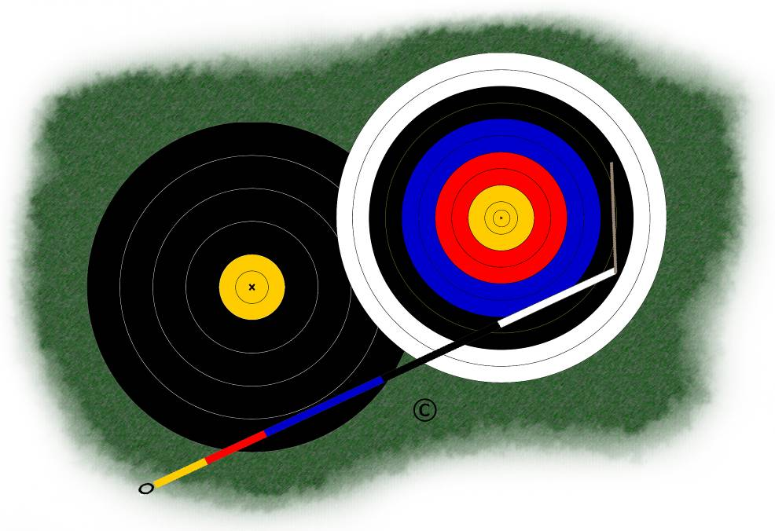

Personal Archery Equipment Details
Equipment Inventory

Name:
Club Name:
Date Completed:

Bow
Item | Manufacturer | Model | Size, Colour, etc. | Serial no. | Qty | Value (£)
Riser
Hand Grip
Limbs
String
Arrow Rest
Pressure Button
Clicker
Bow Sight
Long Rod
Twin Rods
V-bar Extender
V-bar Holder
Top Rod
Bottom Rod
Balance Weight
TFCs
Dampers

Arrows
Item | Manufacturer | Model | Size, Colour, etc. | Serial no. | Qty | Value (£)
Shafts
Nocks
Nock Inserts
Points
Point Inserts
Fletches

Item | Manufacturer | Model | Size, Colour, etc. | Serial no. | Qty | Value (£)
Shafts
Nocks
Nock Inserts
Points
Point Inserts
Fletches

Shooting Accessories
Item | Manufacturer | Model | Size, Colour, etc. | Serial no. | Qty | Value (£)
Tab
Bracer
Bow Sling
Chest Guard
Quiver
Belt

Shooting-Line Equipment
Item | Manufacturer | Model | Size, Colour, etc. | Serial no. | Qty | Value (£)
Telescope
Tripod
Binoculars
Tent / Bivouac
Chair

Clothing
Item | Manufacturer | Model | Size, Colour, etc. | Serial no. | Qty | Value (£)
Trousers/Skirts
Shirts
Jumpers
Shoes
Hat
Jacket
Waterproofs

Cases, Etc
Item | Manufacturer | Model | Size, Colour, etc. | Serial no. | Qty | Value (£)
Trolley
Bow Case
Arrow Case
Accessories Case
Clothing Bag

Tools
Item | Manufacturer | Model | Size, Colour, etc. | Serial no. | Qty | Value (£)

Spares and Accessories
Item | Manufacturer | Model | Size, Colour, etc. | Serial no. | Qty | Value (£)

Summary
Item | Value (£)
Bow
Arrows 1
Arrows 2
Shooting Accessories
Shooting Line Equipment
Clothing
Cases, Etc
Tools
Spares & Accessories
Grand Total

Important Note: A copy of this form should be kept in a safe place away from the equipment itself. In case of loss or theft of your archery equipment, you will then have a record that will be useful to support an insurance claim and help in the replacement.

