Archers’ Forms

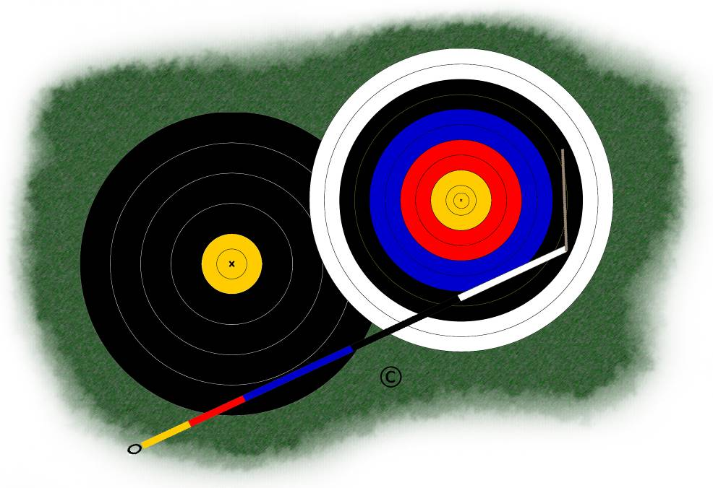

Personal Best Record

Name:
Club Name:
Bow Type:

Target Archery – Outdoors (Imperial Scoring)
Doz. | Round | Personal Best | Date | Venue
12 | York
 | York – double
 | Hereford / Bristol 1
 | Hereford / Bristol 1 - double
 | Bristol 2
 | Bristol 2 - double
 | Bristol 3
 | Bristol 3 - double
 | Bristol 4
 | Bristol 4 - double
 | Bristol 5
 | Bristol 5 - double
9 | St George
 | Albion
 | Windsor
 | Short Windsor
 | Junior Windsor
8 | New Western
 | Long Western
 | Western
 | Short Western
 | Junior Western
 | Short Junior Western
7½ | American
 | American – double
 | St Nicholas
6 | New National
 | Long National
 | National
 | National - double
 | Short National
 | Junior National
 | Short Junior National
4 | New Warwick
 | Long Warwick
 | Warwick
 | Short Warwick
 | Junior Warwick
 | Short Junior Warwick

Note: all double/combination rounds are included in the same section as their component round(s).

Target Archery – Outdoors (Metric Scoring)
Doz. | Round | Personal Best | Date | Venue
12 | FITA (G)
 | FITA (G) – double
 | FITA (L) / Cadet FITA (G) / Metric 1
 | FITA (L) / Cadet FITA (G) / Metric 1 – double
 | Cadet FITA (L) / Metric 2
 | Cadet FITA (L) / Metric 2– double
 | Metric 3
 | Metric 3– double
 | Metric 4
 | Metric 4– double
 | Metric 5
 | Metric 5– double
6 | Long Metric (G)
 | Long Metric (L) / 1
 | Long Metric 2
 | Long Metric 3
 | Long Metric 4
 | Long Metric 5
6 | Short Metric (G) / (L) / 1
 | Short Metric 2
 | Short Metric 3
 | Short Metric 4
 | Short Metric 5
6 | FITA 70m
 | FITA 60m Cadet
3 | 90m distance 122cm face
 | 70m distance 122cm face
 | 60m distance 122cm face
 | 50m distance 122cm face
 | 40m distance 122cm face
 | 30m distance 122cm face
 | 20m distance 122cm face
 | 50m distance 80cm face
 | 40m distance 80cm face
 | 30m distance 80cm face
 | 20m distance 80cm face
 | 15m distance 80cm face
 | 10m distance 80cm face
3 | 30m Winter League (Frostbite)

Note: all double/combination rounds are included in the same section as their component round(s).

Target Archery – Indoors
Doz. | Round | Personal Best | Date | Venue
6 | Stafford
5 | Portsmouth
 | Portsmouth - double
 | Worcester
 | Worcester - double
 | Vegas
 | Vegas – double
 | FITA 18
 | FITA 25
 | Combined FITA (25m + 18m)
2½ | Bray 1
 | Bray 2

Field Archery
 | Round | Personal Best | Date | Venue
 | FITA 24 unmarked (6-zone)
 | FITA 24marked (6-zone)
 | FITA 24 combined (24u/m + 24m) (6-zone)
 | FITA 24 mixed (6-zone)
 | FITA 24 mixed - double (6-zone)
 | FITA 28 unmarked (6-zone)
 | FITA 28 marked (6-zone)
 | FITA 28 combined (28 u/m + 28 m) (6-zone)
 | Stamp unmarked
 | Stamp marked
 | Stamp combined
 | Stamp combination
 | Foresters
 | Foresters - double
 | Four-shot Foresters
 | Big Game
 | National Animal

Clout Archery
 | Round (Distance According to Gender/Age) | Personal Best | Date | Venue
 | 1-way – single (…….… yds) (Imperial)
 | 1-way - double (………. yds) (Imperial)
 | 2-way - single (….…… yds) (Imperial)
 | 2-way - double (…….… yds) (Imperial)
 | 1-way – single (…….… m) (Metric)
 | 1-way - double (…….… m) (Metric)
 | 2-way - single (…….… m) (Metric)
 | 2-way - double (…….… m) (Metric)

Note: all double/combination rounds are included in the same section as their component round(s).

